Query the view to calculate regional CLTV metrics
This SQL query aggregates revenue, order volume, and customer counts from geographic_cohorts to calculate Average Order Value, Purchase Frequency, and Historical CLTV by region. The output ranks regions by descending CLTV, showing that the North Region yields the highest value per customer ($13,532.55), while the South Region leads in total customer volume.

QUERY-;
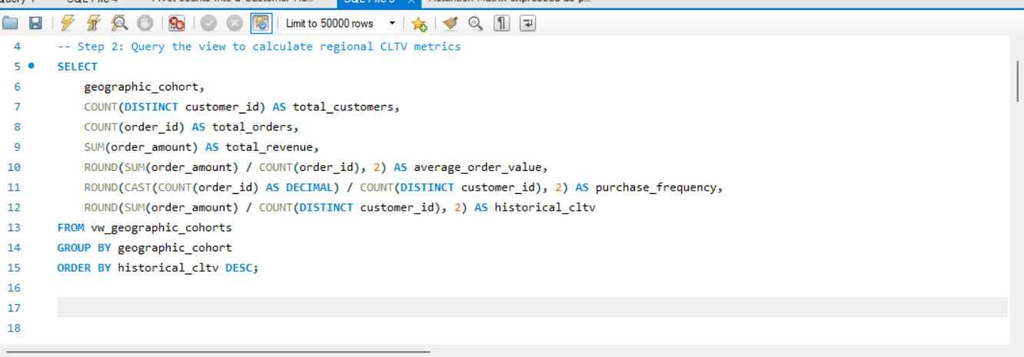

OUTPUT-;

